**INTEGRATION DOCUMENTATION**

Importation of data from MySQL database to excel.

To export data from MySQL:

1. Open MySQL workbench, navigate and open the database (schema).
2. Right click and select TABLE DATA EXPORT WIZARD.
3. Select the columns to export.
4. Select the type of output file, i.e., .csv or .json.
5. Input the file name and click next to continue the process.

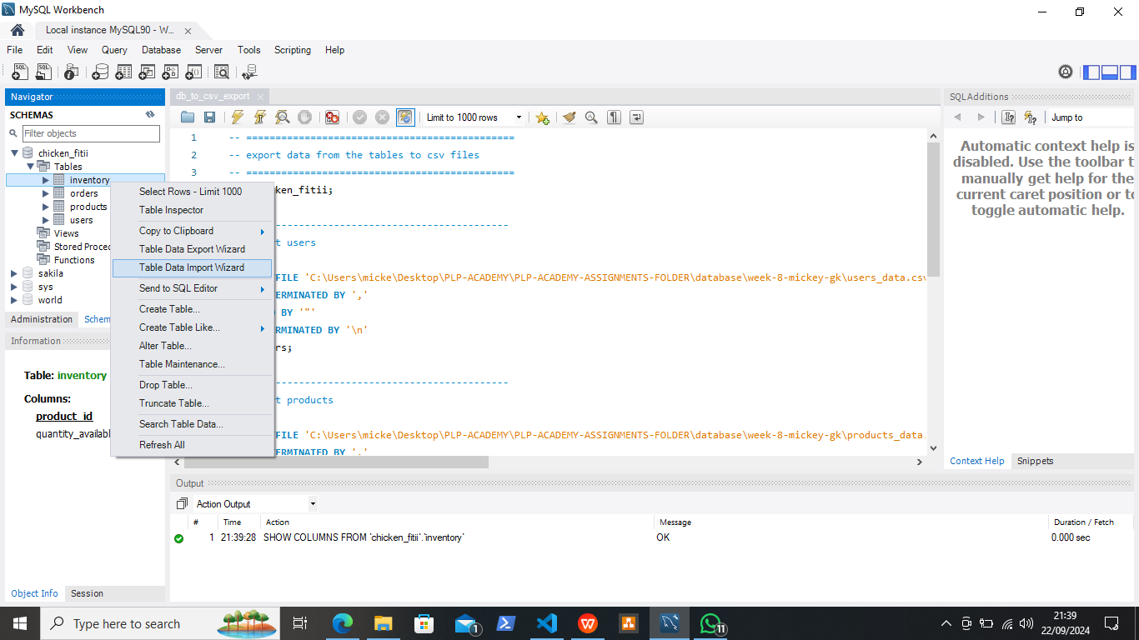

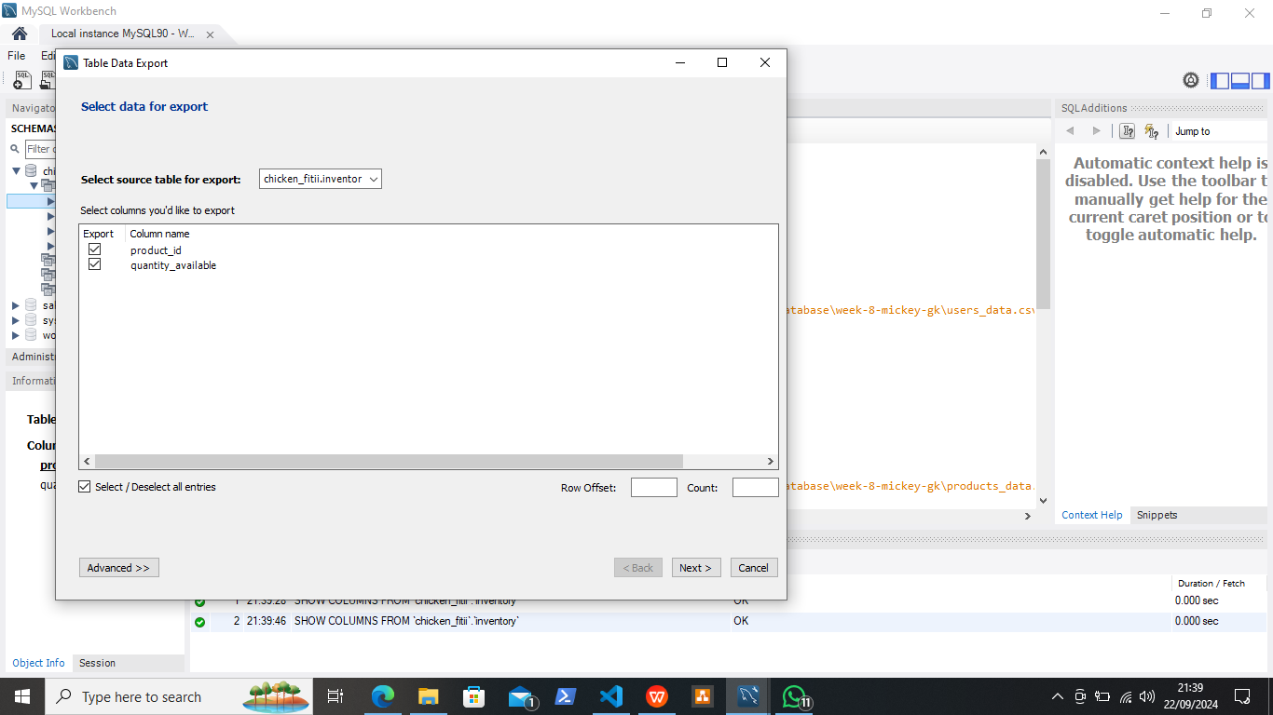

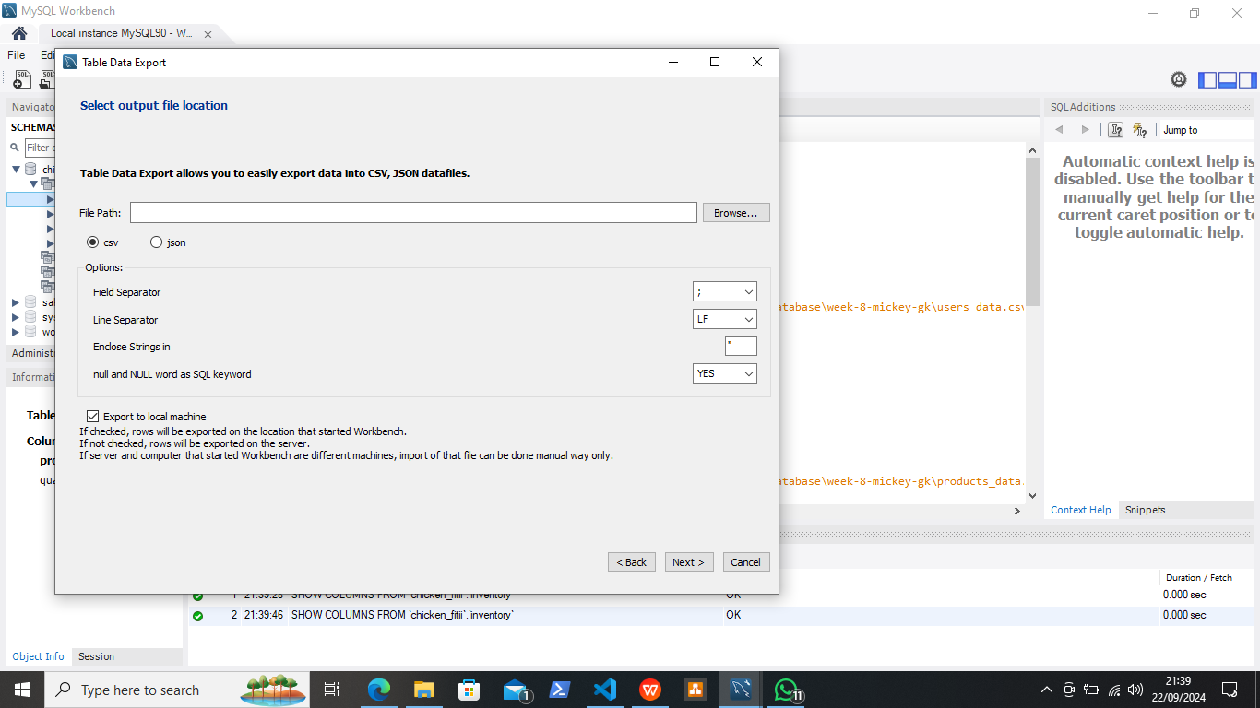

To import data into excel:

1. Open excel app and click on data, click on import data.
2. Select data to import and click next.
3. Select the filename and click open.

